Value Proposition & Analysis of barriers to entering the market
Tasks:
- Value proposition (how the product/service solves the customer problem, core features that differentiate the solution, why now is the right time for this solution, why should a customer choose your solution?)

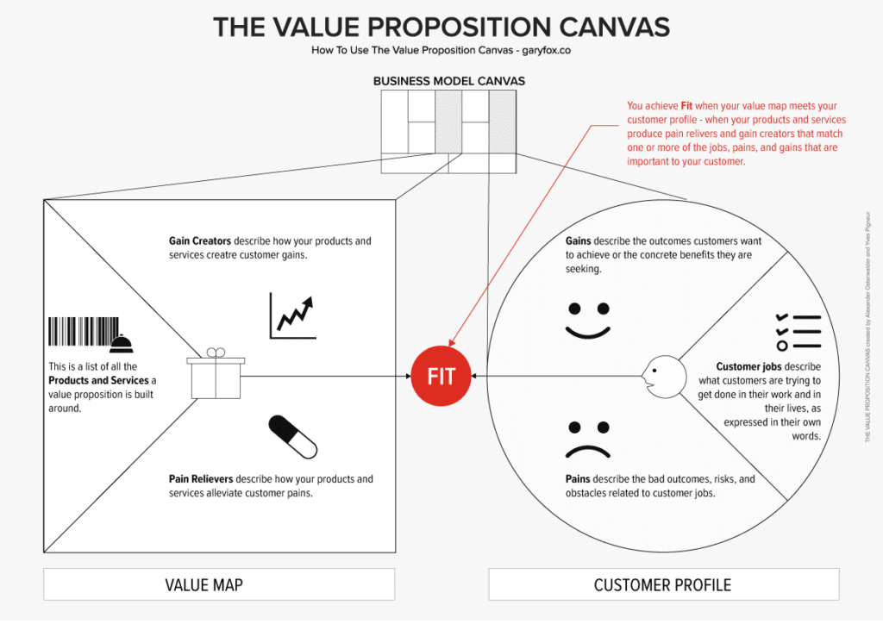

What my product / service does….

How it helps my customer….

The core features are:

Why now is the best time to buy my product /service:

2) Unique Selling Proposition (USP) Explain why your solution is different and better than competitors

Using the table below as template, take some time to review the points of difference between you and your competitors, highlight from your research which factors mean most to the customers when choosing who to shop with.

 | My product/service | Competitor1: | Competitor 2:
Feature
Feature
Feature
Feature
Feature
Feature
Feature

3) Barriers to introduce the service/product in the market and actions

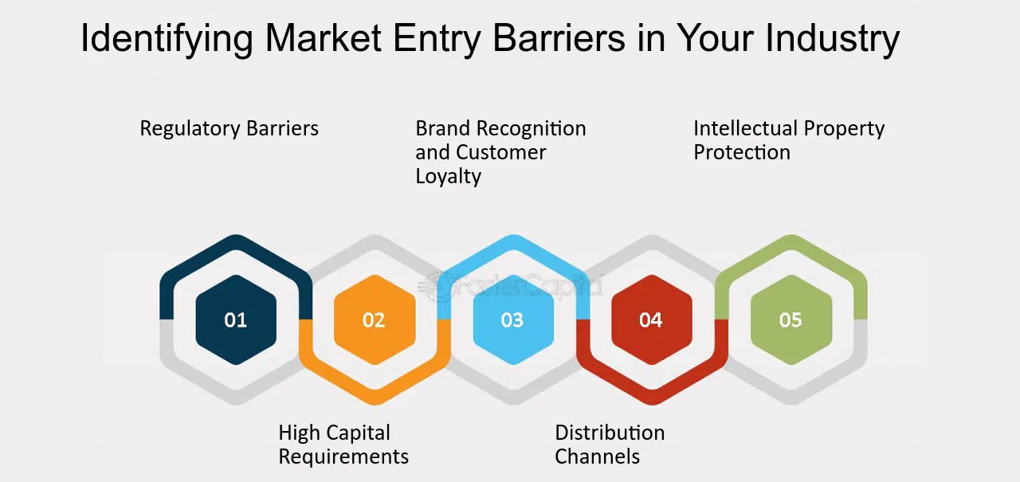
Which of the factors above do you feel will most impact your business? Rank them and outline some actions you can take to overcome these obstacles.

