Masterclass Week4
ANALYSING COMPETITORS AND COMPETITVE ADVANTAGE

Key learning points: How to identify your competitors and be clear on your points of difference.
Tasks:
- Identify and categorise direct and indirect competitors.

Competitor Name | Why are they competition for my business: | Direct competitor?  How? | Indirect Competitor?  How? | What actions I can take to stand out:

1.a Based on the above, who is your number one competitor and why?

- Review Porters 5 Forces and complete the following diagram:

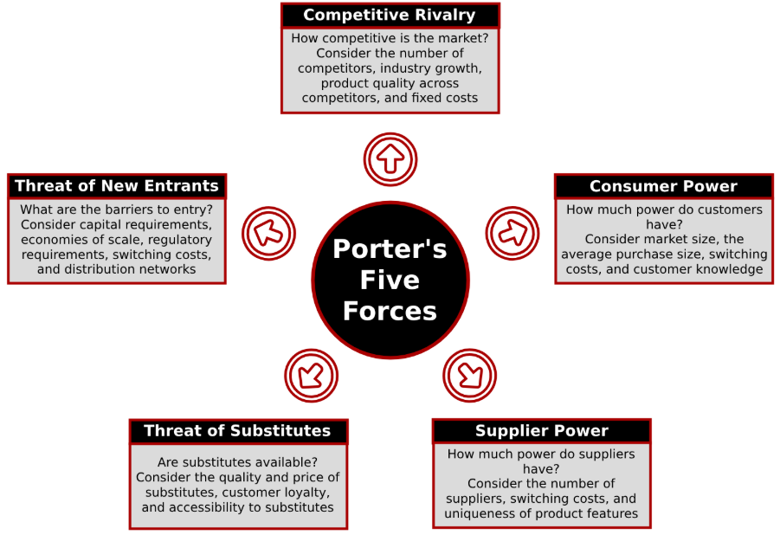

Based on your understanding and research:
 | Threat of substitutes | Threat of new entrants | Supplier Power | Buyer/Consumer Power
Is this high or low for you?

Why?

- How much competitive rivalry is there in your industry or segment?

