Masterclass Week3
DEFINING YOUR SOLUTION
Tasks:
Using the PESTLE framework, research into the current landscape you are launching your idea into, what are the pro’s and cons to consider and what are things that will impact your business be it now or in the future.
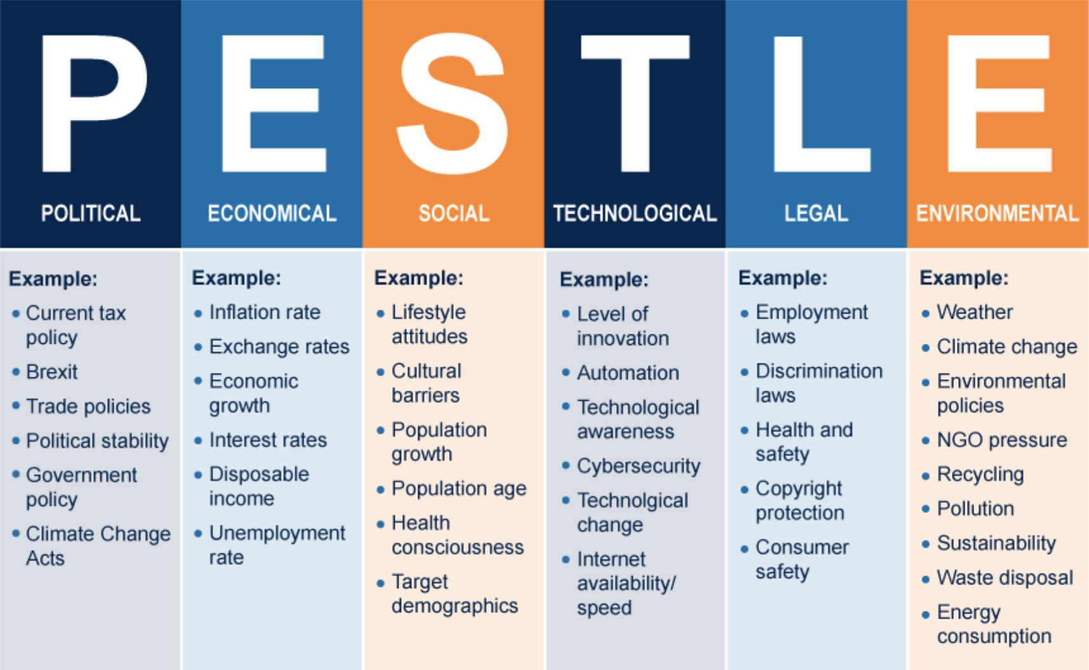
For example:
‘The new laws around single use plastic, this impacts many industries - most prevalent is the food industry. If you are a food business, this will impact who you buy from and what products. It may also have an effect on your costs as the alternatives could cost more, or need you to purchase larger quantities. Look at the example below to see how you might complete the PESTLE exercise:

 | Pros | Cons
Political | Policies and programmes are in place to support businesses making the switch to plastic free | New tariffs and Brexit might make it harder to source products- especially from the EU that are already compliant.
Economical | If you are a provider to the food industry you can see rapid growth and demand in your plastic free products | Changing your suppliers and supplies can be a costly investment initially, as well as stock you may not be able to use.
Societal | People care more about businesses showing they are eco conscious | People prefer plastic in some instances for example- paper straws, meaning you may have to find more expensive alternatives
Technological | Newer tech and materials are always being developed and will eventually become more accessible | Newer materials often cost more, are harder to access or come from abroad so it is riskier when placing large order to assess quality.
Legal | Once you have made the switches, it helps you avoid any penalties for not being compliant with the legislation | Proving you are being compliant- there can be costs involved with being audited and getting certifications
Environmental | Using these materials might make customers more likely to shop with you as this could be a strong value of theirs. It might make expanding your business to other countries easier and more attractive. | Stricter legislation could come in the future as more support is need to show environmental support.

